Acct 2101 - Test 2 – Spring 2017
Student: ___________________________________________________________________________
1. Which of the following is not correct for PCAOB (Public Company Accounting Oversight Board)?
A. Inspect, investigate, and enforce auditing standards of public accounting firms
B. Creates financial accounting standards
C. The board consists may include both CPAs and non-CPAs
D. Collect registration fees from public accounting firms

2. Which of the following was not an issue for firms before the existence of SOX?
A. Non-audit services in public accounting firms had a potential conflict of interest since in they performed audits and implemented new process and systems.
B. If operationally unsuccessful, some firms looked to “creative accounting”
C. There was less of a focus on external controls
D. Audit Committees within the Board of Directors did not successfully deal with accounting control issues.
E. Executives of companies felt pressure to succeed

3. Which of the following best describes the COSO category of Control Environment
A. To assure proper risk assessment, key business risks should be identified including an estimate of their significance and the likelihood of occurrence.
B. Top management sets the tone for the organization on ethics and internal controls
C. Assure a separation of responsibilities such as cash receipt verses the recording of cash
D. Develop procedures that assure controls are available to support the flow of transaction information into the annual report.
E. Maintain on-going reporting on key control performance indicators such as number of data entry errors.

4. COSO identified three objectives of Internal Controls. Which of the following best defines these three objectives?
A. Exceed performance and profit targets, enforce quality control, and checks that laws and guidelines are met.
B. Make for more efficient production, checks that laws and regulations are being followed, and follows SOX's 5 internal controls.
C. Meet Performance and profit targets, increases production efficiency, and enforces quality control.
D. Achieve effectiveness and efficiency of operations, achieve compliance with the applicable laws and regulations, and ensure reliable financial reports.
E. None of the above

5. Which of the following module(s) of COSO (The committee of Sponsoring Organizations of the Treadway Commission) is responsible for the analysis of relevant factors to achieve objectives, forming a basis for determining how any danger should be managed?
A. Control environment
B. Risk assessment
C. Control activities
D. Information & communication
E. Monitoring

6. Which of the following was not a factor in Betty Vinson going to jail?
A. She did what her bosses told her to do.
B. She accepted a significant promotion in the firm.
C. She was assured by her management that what she was doing was within the rules and that they would support her if there was any issues.
D. She was the prime breadwinner for the family.
E. She did not have a true understanding of the impact of her actions in terms of ethics and legality.

7. Which of the following is a typical internal control?
A. The use of password-protected computers and software.
B. The person who approves Invoices for payment should be different from the person who signs the checks. The requirement that separate individuals authorize cash disbursements and sign checks.
C. The use of physical controls over inventories to prevent loss from theft.
D. A physical count of inventory at year-end to verify amounts shown on the company's accounting records.
E. All of the above, All of the other answers are correct.

8. The Sarbanes-Oxley Act, Management Assessment of Internal Controls, includes all of the following except:
A. A statement of management's responsibility for establishing the internal control structure.
B. A waiver of auditor responsibility for assessing management's report on internal controls.
C. An assessment of the effectiveness of internal controls by management.
D. An assessment of the effectiveness of procedures for financial reporting by management.
E. A requirement that management include in its annual report an internal control report.

9. Which of the following is not a benefit of budgeting?
A. It reduces the need for tracking actual cost activity.
B. It sets benchmarks for evaluation performance.
C. it has proved to be an excellent training for management.
D. It assures coordination between the key functions of the company such as sales, manufacturing, product delivery, etc.
E. It reinforces the need for communication by top management to the employees on the direction the company plans to take.

10. The break-even point is that level of activity where:
A. variable cost equals fixed cost.
B. contribution margin equals fixed cost.
C. total contribution margin equals the sum of variable cost plus fixed cost.
D. sales revenue equals total variable cost.
E. sales revenue equals fixed cost.

11. Assuming no change in sales volume, an increase in company's per-unit contribution margin would:
A. increase income.
B. decrease income.
C. have no effect on income.
D. increase fixed costs.
E. decrease fixed costs.

12. At a volume of 20,000 units, Dries reported sales revenues of $1,000,000, variable costs of $300,000, and fixed costs of $260,000. The company's break-even point in units is:
A. 7,027 (rounded).
B. 8,667 (rounded).
C. 9,286 (rounded).
D. 7,429 (rounded).
E. None of the other answers is correct.

13. A recent income statement of Yang Corporation reported the following data:
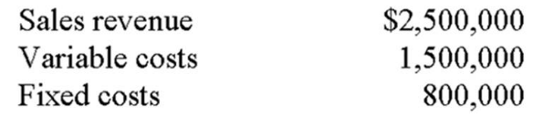
If the above data are based on the sale of 5,000 units, the break-even sales would be:
A. $2,000,000.
B. $2,206,000.
C. $2,500,000.
D. $10,000,000.
E. None of the other answers is correct.

14. At a volume level of 500,000 units, Sullivan reported the following information:
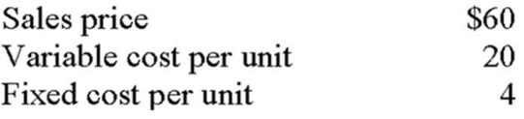
The company's contribution-margin ratio is closest to:
A. 0.33.
B. 0.40.
C. 0.60.
D. 0.67.
E. None of the other answers is correct.

15. 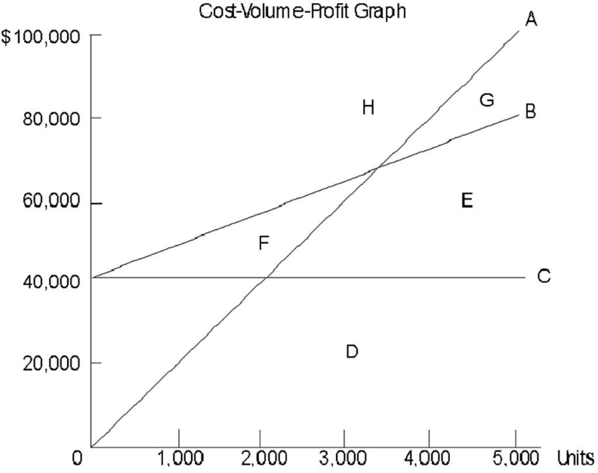
Refer to the figure above. Assume that the company whose cost structure is depicted in the figure expects to produce a loss for the upcoming period. The loss would be shown on the graph:
A. by the area immediately above the break-even point (letter "H").
B. by the area immediately below the total cost line. (letter "E")
C. by the area diagonally to the right of the break-even point (letter "G").
D. by the area diagonally to the left of the break-even point (letter "H").
E. Any of the other areas or lines.

16. Yellow Dot, Inc. sells a single product for $10. Variable costs are $4 per unit and fixed costs total $120,000 at a volume level of 10,000 units. What dollar sales level would Yellow Dot have to achieve to earn a target profit of $240,000?
A. $400,000.
B. $500,000.
C. $600,000.
D. $750,000.
E. $900,000.

17. To improve the safety margin, which of the following should happen::
A. increase sales dollars break even.
B. increase the variable cost per unit
C. decrease selling prices, assuming the price change will have no effect on demand.
D. stimulate sales volume growth.
E. None of the above

18. Which of the following is not an underlying assumptions of cost-volume-profit analysis?
A. Revenues and costs categorized as variable or fixed,
B. Revenues and costs behave in a linear manner
C. Units sold and produced are the same number
D. Fixed cost remains constant within the relevant range
E. Differences of units sold and produced are highlighted

19. Miller Company has an operating leverage factor of 5. Which of the following statements is true?
A. An 8% change in income should result in a 40% change in sales revenue.
B. An 8% change in sales revenue should result in a 40% change in income.
C. An 8% change in variable costs should result in a 40% change in contribution margin.
D. An 8% change in fixed costs should result in a 40% change in income.
E. An 8% change in variable costs should result in a 40% change in break-even sales.

20. Loren Company's single product has a selling price of $15 per unit. Last year the company reported total variable expenses of $180,000, fixed expenses of $90,000, and a net operating income of $30,000. A study by the sales manager discloses that a 15% increase in the selling price would reduce unit sales by 10%. If her proposal is adopted, net operating income would:
A. increase by $45,000
B. increase by $37,500
C. increase by $7,500
D. increase by $28,500

USE THE FOLLOWING INFORMATIOAN TO ANSWER THE NEXT QUESTION
The following data pertain to Epsom Corporation's operations:
Unit sales | 12,000 units
Selling price | $25 per unit
Contribution margin ratio | 40%
Margin of safety | $90,000
21. The break-even level in sales dollars is:
A. $210,000
B. $120,000
C. $180,000
D. $84,000

22. The break-even point in unit sales is found by dividing total fixed expenses by:
A. the contribution margin ratio.
B. the variable expenses per unit.
C. the sales price per unit.
D. the contribution margin per unit.

USE THE FOLLOWING INFORMATION TO ANSWER THE NEXT QUESTION
Data concerning Homme Corporation's single product appear below:
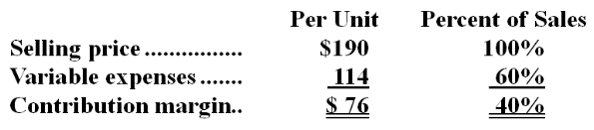
The company is currently selling 2,000 units per month. Fixed expenses are $130,000 per month.
23. The marketing manager would like to introduce sales commissions as an incentive for the sales staff. The marketing manager has proposed a commission of $14 per unit. In exchange, the sales staff would accept a decrease in their salaries of $24,000 per month. (This is the company's savings for the entire sales staff.) The marketing manager predicts that introducing this sales incentive would increase monthly sales by 100 units. What should be the overall effect on the company's monthly net operating income of this change?
A. Decrease of $45,800
B. Increase of $154,200
C. Increase of $22,600
D. Increase of $2,200

24. Butteco Corporation has provided the following cost data for last year when 100,000 units were produced and sold:
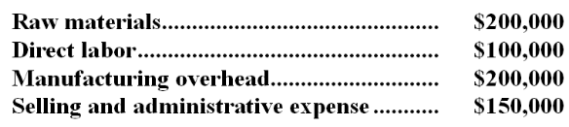
All costs are variable except for $100,000 of manufacturing overhead and $100,000 of selling and administrative expense. There are no beginning or ending inventories. If the selling price is $10 per unit, the net operating income from producing and selling 110,000 units would be:
A. $450,000
B. $385,000
C. $405,000
D. $560,000

25. Wilmar Corporation is budgeting its equipment needs on an on-going basis, with a new quarter being added to the budget as the current quarter is completed. This type of budget is most commonly known as a:
A. capital budget.
B. rolling budget.
C. revised budget.
D. pro-forma budget.
E. financial budget.

26. The master budget contains the following components, among others: (1) direct-material budget, (2) budgeted balance sheet, (3) production budget, and (4) cash budget. Which of these components would be prepared first and which would be prepared last? There are more than the four budgets mentioned above. This question is asking what is the sequence for these four budgets only.
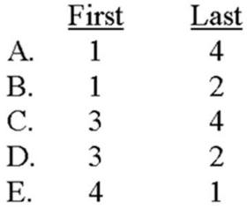
A. Choice A
B. Choice B
C. Choice C
D. Choice D
E. Choice E

27. Bison Sporting Goods sells bicycles throughout the northeastern United States. The following data were taken from the most recent quarterly sales forecast:
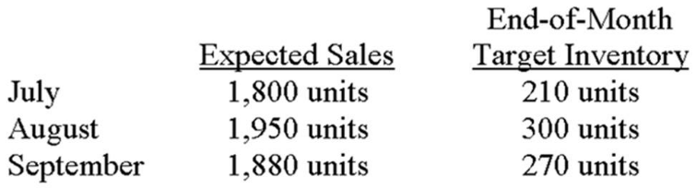
On the basis of the information presented, how many bicycles should the company purchase in August?
A. 1,860.
B. 1,950.
C. 2,040.
D. 2,250.
E. None of the other answers are correct.

28. Swansong plans to sell 10,000 units of a particular product during July, and expects sales to increase at the rate of 10% per month during the remainder of the year. The June 30 and September 30 ending inventories are anticipated to be 1,100 units and 950 units, respectively. On the basis of this information, how many units should Swansong purchase for the quarter ended September 30?
A. 31,850.
B. 32,150.
C. 32,950.
D. 33,250.
E. None of the other answers are correct.

29. Northcutt's production data for a new deluxe product were taken from the most recent quarterly production budget:
In addition, Northcutt produces 5,000 units a month of its standard product. It takes two direct labor hours to produce each standard unit and 2.25 direct labor hours to produce each deluxe unit. Northwest's cost per labor hour is $15. Direct labor cost for July would be budgeted at:
A. $183,750.
B. $187,125.
C. $189,125.
D. $194,750.
E. None of the other answers are correct.

30. Verna's makes all sales on account, subject to the following collection pattern: 20% are collected in the month of sale; 70% are collected in the first month after sale; and 10% are collected in the second month after sale. If sales for October, November, and December were $70,000, $60,000, and $50,000, respectively, what was the budgeted receivables balance on December 31?
A. $40,000.
B. $46,000.
C. $49,000.
D. $59,000.
E. None of the other answers are correct.

31. The following selected data pertain to Phineus Corporation:
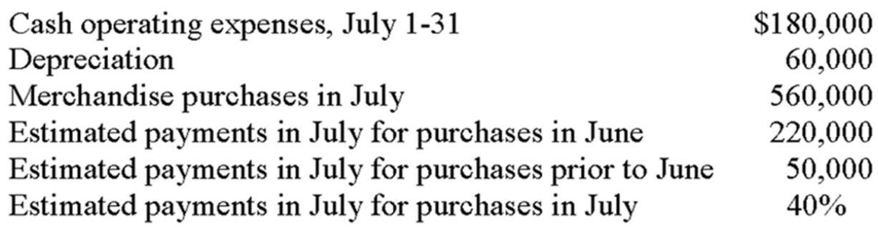
July's cash disbursements are expected to be:
A. $404,000.
B. $464,000.
C. $674,000.
D. $734,000.
E. None of the other answers are correct.

32. Wolverine, Inc. began operations on January 1 of the current year with a $12,000 cash balance. Forty percent of sales are collected in the month of sale; 60% are collected in the month following sale. Similarly, 20% of purchases are paid in the month of purchase, and 80% are paid in the month following purchase. The following data apply to January and February:
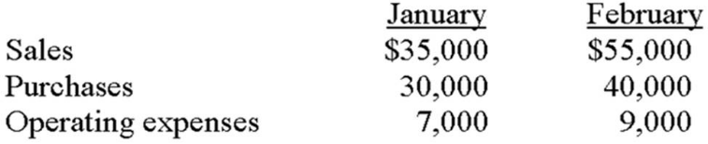
If operating expenses are paid in the month incurred and include monthly depreciation charges of $2,500, determine the change in Wolverine's cash balance during February.
A. $2,000 increase.
B. $4,500 increase.
C. $5,000 increase.
D. $7,500 increase.
E. None of the other answers are correct.

33. End-of-period figures for accounts receivable and payables to suppliers would be found on the:
A. cash budget.
B. budgeted schedule of cost of goods manufactured.
C. budgeted income statement.
D. budgeted balance sheet.
E. budgeted statement of cash flows.

34. Consider the following statements about companies that are involved with international operations:
I. Budgeting for these firms is often very involved because of fluctuating values in foreign currencies.
II. Multinational firms may encounter hyperinflationary economies.
III. Such organizations often face changing laws and political climates that affect business activity.
Which of the above statements is (are) true?
A. I only.
B. III only.
C. I and II.
D. II and III.
E. I, II, and III.

35. Company A uses a heavily participative budgeting approach whereas at Company B, top management develops all budgets and imposes them on lower-level personnel. Which of the following statements is false?
A. A's employees will likely be more motivated to achieve budgetary goals than the employees of Company B.
B. B's employees may be somewhat disenchanted because although they will be evaluated against a budget, they really had little say in budget development.
C. Budget padding will likely be a greater problem at Company B.
D. Budget preparation time will likely be longer at Company A.
E. Ethical issues are more likely to arise at Company A, especially when the budget is used as a basis for performance appraisal.

USE THE FOLLOWING INFORMATION TO ANSWER THE NEXT QUESTION
Sartain Corporation is in the process of preparing its annual budget. The following beginning and ending inventory levels are planned for the year. Sales are projected to be 670,000 units for the year.
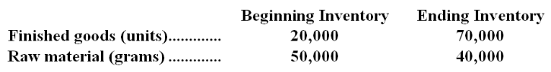
Each unit of finished goods requires 2 grams of raw material.
36. How much of the raw material should the company purchase during the year?
A. 1,430,000 grams
B. 1,450,000 grams
C. 1,480,000 grams
D. 1,440,000 grams

37. The manufacturing overhead budget at Latronica Corporation is based on budgeted direct labor-hours. The direct labor budget indicates that 7,100 direct labor-hours will be required in August. The variable overhead rate is $8.60 per direct labor-hour. The company's budgeted fixed manufacturing overhead is $132,770 per month, which includes depreciation of $24,850. All other fixed manufacturing overhead costs represent current cash flows. The company recomputes its predetermined overhead rate every month. The predetermined overhead rate for August should be:
A. $8.60
B. $27.30
C. $23.80
D. $18.70
E. $12.10

38. The selling and administrative expense budget of Breckinridge Corporation is based on budgeted unit sales, which are 5,500 units for June. The variable selling and administrative expense is $1.00 per unit. The budgeted fixed selling and administrative expense is $101,200 per month, which includes depreciation of $6,050 per month. The remainder of the fixed selling and administrative expense represents current cash flows. The cash disbursements for selling and administrative expenses on the June selling and administrative expense budget should be:
A. $100,650
B. $106,700
C. $5,500
D. $95,150

USE THE FOLLOWING INFORMATION TO ANSWER THE NEXT QUESTION
Carpon Lumber sells lumber and general building supplies to building contractors in a medium-sized town in Montana. Data regarding the store's operations follow:
• Sales are budgeted at $340,000 for November, $350,000 for December, and $370,000 for January.
• Collections are expected to be 55% in the month of sale, 44% in the month following the sale, and 1% uncollectible.
• The cost of goods sold is 75% of sales.
• The company desires to have an ending merchandise inventory equal to 60% of the next month's cost of goods sold. Payment for merchandise is made in the month following the purchase.
• Other monthly expenses to be paid in cash are $21,100.
• Monthly depreciation is $19,000.
• Ignore taxes.
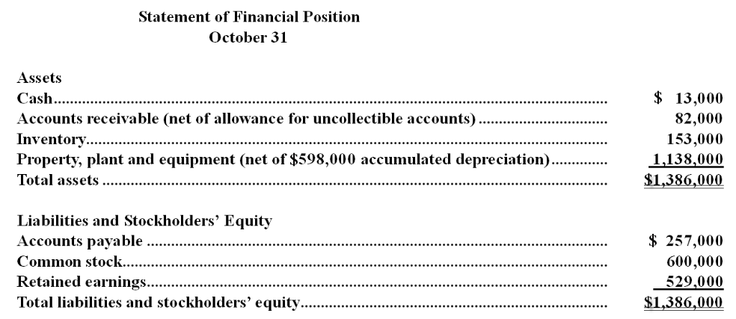
39. Accounts payable at the end of December would be:
A. $271,500
B. $105,000
C. $166,500
D. $262,500

40. The Willsey Merchandise Company has budgeted $40,000 in sales for the month of December. The company's cost of goods sold is 30% of sales. If the company has budgeted to purchase $18,000 in merchandise during December, then the budgeted change in inventory levels over the month of December is:
A. $6,000 increase
B. $10,000 decrease
C. $22,000 decrease
D. $15,000 increase

Acct 2101 - Test 2 - F14 Key
1. Which of the following is not correct for PCAOB (Public Company Accounting Oversight Board)?
A. Inspect, investigate, and enforce auditing standards of public accounting firms
B. Set financial accounting standards
C. The board may include both CPAs and non-CPAs
D. Collect registration fees from public accounting firms

2. Which of the following was not an issue for firms before the existence of SOX?
A. Non-audit services in public accounting firms had a potential conflict of interest in they performed audits and implemented new process and systems.
B. If operationally unsuccessful, some firms looked to “creative accounting”
C. There was less of a focus on external controls
D. Audit Committees within Board of Directors did not successfully deal with accounting control issues.
E. Executives of companies felt pressure to succeed

3. Which of the following best describes the COSO category of Control Environment
A. To assure proper risk assessment, key business risks should be identified including an estimate of their significance and the likelihood of occurrence.
B. Top management sets the tone for the organization on ethics and internal controls
C. Assure a separation of responsibilities such as cash receipt verses the recording of cash
D. Develop procedures that assure controls are available to support the flow of transaction information into the annual report.
E. Maintain on-going reporting on key control performance indicators such as number of data entry errors.

4. COSO identified three objectives of Internal Controls. Which of the following best defines these three objectives?
A. Exceed performance and profit targets, enforce quality control, and checks that laws and guidelines are met.
B. Make for more efficient production, checks that laws and regulations are being followed, and follows SOX's 5 internal controls.
C. Meet Performance and profit targets, increases production efficiency, and enforces quality control.
D. Achieve effectiveness and efficiency of operations, achieve compliance with the applicable laws and regulations, and ensure reliable financial reports.
E. None of the above

5. Which of the following module(s) of COSO (The committee of Sponsoring Organizations of the Treadway Commission) is responsible for the analysis of relevant factors to achieve objectives, forming a basis for determining how any danger should be managed?
A. Control environment
B. Risk assessment
C. Control activities
D. Information & communication
E. Monitoring
6. Which of the following was not a factor in Betty Vinson going to jail?
A. She did what her bosses told her to do.
B. She accepted a significant promotion in the firm.
C. She was assured by her management that what she was doing was within the rules and that they would support her if there was any issues.
D. She was the prime breadwinner for the family.
E. She did not have a true understanding of the impact of her actions in terms of ethics and legality.

Being the prime breadwinner contributed to the pressure for her to go along with what her bosses told her to do, while she did accept a promotion after doing items she knew was wrong.
AACSB: Ethics
AICPA BB: Legal
AICPA FN: Risk Analysis
Blooms: Understand
Difficulty: 1 Easy
Hilton - Appendix I... #1
Learning Objective: I-01 Understand and discuss the concept of internal controls over financial reporting.

7. Which of the following is a typical internal control?
A. The use of password-protected computers and software.
B. The requirement that separate individuals authorize cash disbursements and sign checks.
C. The use of physical controls over inventories to prevent loss from theft.
D. A physical count of inventory at year-end to verify amounts shown on the company's accounting records.
E. All of the other answers are correct.

AACSB: Ethics
AICPA BB: Industry
AICPA FN: Risk Analysis
Blooms: Understand
Difficulty: 2 Medium
Hilton - Appendix I... #3
Learning Objective: I-01 Understand and discuss the concept of internal controls over financial reporting.
8. Section 404 of the Sarbanes-Oxley Act, Management Assessment of Internal Controls, includes all of the following except:
A. A statement of management's responsibility for establishing the internal control structure.
B. A waiver of auditor responsibility for assessing management's report on internal controls.
C. An assessment of the effectiveness of internal controls by management.
D. An assessment of the effectiveness of procedures for financial reporting by management.
E. A requirement that management include in its annual report an internal control report.

AACSB: Ethics
AICPA BB: Industry
AICPA FN: Research
Blooms: Understand
Difficulty: 2 Medium
Hilton - Appendix I... #10
Learning Objective: I-02 Understand and discuss the role of the PCAOB and the implications of Sarbanes-Oxley Sections 302 and 404.

9. Which of the following is not a benefit of budgeting?
A. It reduces the need for tracking actual cost activity.
B. It sets benchmarks for evaluation performance.
C. it has proved to be an excellent training for management.
D. It assures coordination between the key functions of the company such as sales, manufacturing, product delivery, etc.
E. It reinforces the need for communication by top management to the employees on the direction the company plans to take.

AACSB: Reflective Thinking
AICPA BB: Critical Thinking
AICPA FN: Measurement
Blooms: Knowledge
Garrison - Chapter 08 #12
Learning Objective: 08-01 Understand why organizations budget and the processes they use to create budgets
Level: Easy

10. The break-even point is that level of activity where:
A. variable cost equals fixed cost.
B. contribution margin equals fixed cost.
C. total contribution margin equals the sum of variable cost plus fixed cost.
D. sales revenue equals total variable cost.
E. sales revenue equals fixed cost.

AACSB: Reflective Thinking
AICPA BB: Critical Thinking
AICPA FN: Research
Blooms: Remember
Difficulty: 1 Easy
Hilton - Chapter 07 #8
Learning Objective: 07-01 Compute a break-even point using the contribution-margin approach and the equation approach.
11. Assuming no change in sales volume, an increase in company's per-unit contribution margin would:
A. increase income.
B. decrease income.
C. have no effect on income.
D. increase fixed costs.
E. decrease fixed costs.

AACSB: Reflective Thinking
AICPA BB: Critical Thinking
AICPA FN: Research
Blooms: Understand
Difficulty: 2 Medium
Hilton - Chapter 07 #15
Learning Objective: 07-01 Compute a break-even point using the contribution-margin approach and the equation approach.
12. At a volume of 20,000 units, Dries reported sales revenues of $1,000,000, variable costs of $300,000, and fixed costs of $260,000. The company's break-even point in units is:
A. 7,027 (rounded).
B. 8,667 (rounded).
C. 9,286 (rounded).
D. 7,429 (rounded).
E. None of the other answers is correct.

AACSB: Analytic
AICPA BB: Critical Thinking
AICPA FN: Measurement
Blooms: Apply
Difficulty: 3 Hard
Hilton - Chapter 07 #20
Learning Objective: 07-01 Compute a break-even point using the contribution-margin approach and the equation approach.
13. A recent income statement of Yang Corporation reported the following data:
If the above data are based on the sale of 5,000 units, the break-even sales would be:
A. $2,000,000.
B. $2,206,000.
C. $2,500,000.
D. $10,000,000.
E. None of the other answers is correct.

AACSB: Analytic
AICPA BB: Critical Thinking
AICPA FN: Measurement
Blooms: Apply
Difficulty: 3 Hard
Hilton - Chapter 07 #24
Learning Objective: 07-01 Compute a break-even point using the contribution-margin approach and the equation approach.
14. At a volume level of 500,000 units, Sullivan reported the following information:
The company's contribution-margin ratio is closest to:
A. 0.33.
B. 0.40.
C. 0.60.
D. 0.67.
E. None of the other answers is correct.

AACSB: Analytic
AICPA BB: Critical Thinking
AICPA FN: Measurement
Blooms: Apply
Difficulty: 3 Hard
Hilton - Chapter 07 #31
Learning Objective: 07-02 Compute the contribution-margin ratio and use it to find the break-even point in sales dollars.
15.
Refer to the figure above. Assume that the company whose cost structure is depicted in the figure expects to produce a loss for the upcoming period. The loss would be shown on the graph:
A. by the area immediately above the break-even point (letter "H").
B. by the area immediately below the total cost line. (letter "E")
C. by the area diagonally to the right of the break-even point (letter "G").
D. by the area diagonally to the left of the break-even point (letter "D").
E. Any of the other areas or lines.

AACSB: Reflective Thinking
AICPA BB: Critical Thinking
AICPA FN: Research
Blooms: Remember
Difficulty: 1 Easy
Hilton - Chapter 07 #38
Learning Objective: 07-03 Prepare a cost-volume-profit (CVP) graph and explain how it is used.
16. Yellow Dot, Inc. sells a single product for $10. Variable costs are $4 per unit and fixed costs total $120,000 at a volume level of 10,000 units. What dollar sales level would Yellow Dot have to achieve to earn a target profit of $240,000?
A. $400,000.
B. $500,000.
C. $600,000.
D. $750,000.
E. $900,000.

AACSB: Analytic
AICPA BB: Critical Thinking
AICPA FN: Measurement
Blooms: Apply
Difficulty: 3 Hard
Hilton - Chapter 07 #45
Learning Objective: 07-04 Apply CVP analysis to determine the effect on profit of changes in fixed expenses; variable expenses; sales prices; and sales volume.
17. To improve the safety margin, which of the following should happen::
A. increase sales dollars break even.
B. increase the variable cost per unit
C. decrease selling prices, assuming the price change will have no effect on demand.
D. stimulate sales volume growth.
E. None of the above

AACSB: Reflective Thinking
AICPA BB: Critical Thinking
AICPA FN: Research
Blooms: Understand
Difficulty: 2 Medium
Hilton - Chapter 07 #55
Learning Objective: 07-04 Apply CVP analysis to determine the effect on profit of changes in fixed expenses; variable expenses; sales prices; and sales volume.
18. Which of the following is not an underlying assumptions of cost-volume-profit analysis?
A. Revenues and costs categorized as variable or fixed,
B. Revenues and costs behave in a linear manner
C. Units sold and produced are the same number
D. Fixed cost remains constant within the relevant range
E. Differences of units sold and produced are highlighted

AACSB: Reflective Thinking
AICPA BB: Critical Thinking
AICPA FN: Research
Blooms: Remember
Difficulty: 1 Easy
Hilton - Chapter 07 #66
Learning Objective: 07-06 List and discuss the key assumptions of CVP analysis.
19. Miller Company has an operating leverage factor of 5. Which of the following statements is true?
A. An 8% change in income should result in a 40% change in sales revenue.
B. An 8% change in sales revenue should result in a 40% change in income.
C. An 8% change in variable costs should result in a 40% change in contribution margin.
D. An 8% change in fixed costs should result in a 40% change in income.
E. An 8% change in variable costs should result in a 40% change in break-even sales.

AACSB: Reflective Thinking
AICPA BB: Critical Thinking
AICPA FN: Research
Blooms: Understand
Difficulty: 2 Medium
Hilton - Chapter 07 #74
Learning Objective: 07-08 Explain the role of cost structure and operating leverage in CVP relationships.
20. Loren Company's single product has a selling price of $15 per unit. Last year the company reported total variable expenses of $180,000, fixed expenses of $90,000, and a net operating income of $30,000. A study by the sales manager discloses that a 15% increase in the selling price would reduce unit sales by 10%. If her proposal is adopted, net operating income would:
A. increase by $45,000
B. increase by $37,500
C. increase by $7,500
D. increase by $28,500
Profit = (Sales - Variable expenses) - Fixed expenses
$30,000 = ($15 per unit × Unit sales - $180,000) - $90,000
($15 per unit × Unit sales - $180,000) = $30,000 + $90,000
$15 per unit × Unit sales = $30,000 + $90,000 + $180,000
$15 per unit × Unit sales = $300,000
Unit sales = $300,000 ÷ $15 per unit = 20,000 units
Variable expense per unit = Variable expenses ÷ Unit sales
= $180,000 ÷ 20,000 units = $9 per unit
New selling price = (1.00 + 0.15) × $15 per unit = $17.25 per unit
New unit sales = (1.00 - 0.10) × 20,000 units = 18,000 units
Profit = (P - V) × Q - Fixed expenses
New profit = ($17.25 per unit - $9.00 per unit) × 18,000 units - $90,000
= ($8.25 per unit × 18,000 units) - $90,000
= $148,500 - $90,000
= $58,500
Increase in profit = $58,500 - $30,000 = $28,500

AACSB: Analytic
AICPA BB: Critical Thinking
AICPA FN: Measurement
Blooms: Application
Garrison - Chapter 05 #57
Learning Objective: 05-04 Show the effects on net operating income of changes in variable costs; fixed costs; selling price; and volume
Level: Hard
USE THE FOLLOWING INFORMATIOAN TO ANSWER THE NEXT QUESTION
The following data pertain to Epsom Corporation's operations:
Unit sales | 12,000 units
Selling price | $25 per unit
Contribution margin ratio | 40%
Margin of safety | $90,000
Garrison - Chapter 05
21. The break-even level in sales dollars is:
A. $210,000
B. $120,000
C. $180,000
D. $84,000
Total sales = $25 per unit × 12,000 units = $300,000
Margin of safety percentage = Margin of safety in dollars ÷ Total budgeted (or actual) sales
0.30 = Margin of safety in dollars ÷ $300,000
Margin of safety in dollars = 0.30 × $300,000 = $90,000
Margin of safety in dollars = Total budgeted (or actual) sales - Break-even sales
$90,000 = $300,000 - Break-even sales
Breakeven sales = $300,000 - $90,000 = $210,000

AACSB: Analytic
AICPA BB: Critical Thinking
AICPA FN: Measurement
Blooms: Application
Garrison - Chapter 05 #105
Learning Objective: 05-06 Determine the break-even point
Level: Hard
22. The break-even point in unit sales is found by dividing total fixed expenses by:
A. the contribution margin ratio.
B. the variable expenses per unit.
C. the sales price per unit.
D. the contribution margin per unit.

AACSB: Reflective Thinking
AICPA BB: Critical Thinking
AICPA FN: Measurement
Blooms: Knowledge
Garrison - Chapter 05 #25
Learning Objective: 05-06 Determine the break-even point
Level: Easy
USE THE FOLLOWING INFORMATION TO ANSWER THE NEXT QUESTION
Data concerning Homme Corporation's single product appear below:
The company is currently selling 2,000 units per month. Fixed expenses are $130,000 per month.
Garrison - Chapter 05
23. The marketing manager would like to introduce sales commissions as an incentive for the sales staff. The marketing manager has proposed a commission of $14 per unit. In exchange, the sales staff would accept a decrease in their salaries of $24,000 per month. (This is the company's savings for the entire sales staff.) The marketing manager predicts that introducing this sales incentive would increase monthly sales by 100 units. What should be the overall effect on the company's monthly net operating income of this change?
A. Decrease of $45,800
B. Increase of $154,200
C. Increase of $22,600
D. Increase of $2,200
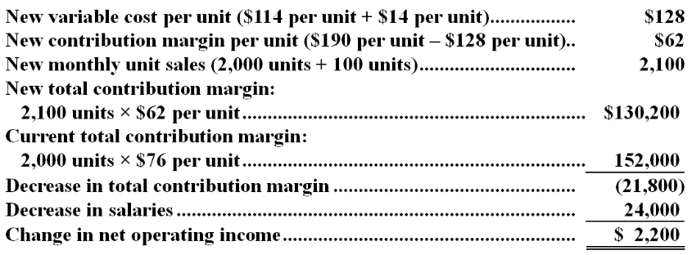

AACSB: Analytic
AICPA BB: Critical Thinking
AICPA FN: Measurement
Blooms: Application
Garrison - Chapter 05 #166
Learning Objective: 05-04 Show the effects on net operating income of changes in variable costs; fixed costs; selling price; and volume
Level: Medium
24. Butteco Corporation has provided the following cost data for last year when 100,000 units were produced and sold:
All costs are variable except for $100,000 of manufacturing overhead and $100,000 of selling and administrative expense. There are no beginning or ending inventories. If the selling price is $10 per unit, the net operating income from producing and selling 110,000 units would be:
A. $450,000
B. $385,000
C. $405,000
D. $560,000
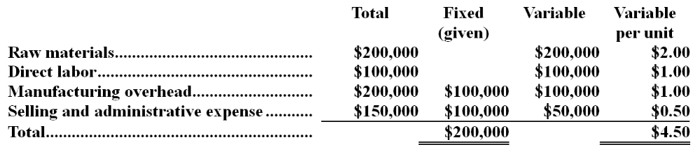
Unit CM = Selling price per unit - Variable expenses per unit
= $10.00 per unit - $4.50 per unit = $5.50 per unit
Profit = Unit CM × Q - Fixed expenses
= ($5.50 per unit × 110,000 units) - $200,000 = $405,000

AACSB: Analytic
AICPA BB: Critical Thinking
AICPA FN: Measurement
Blooms: Application
Garrison - Chapter 05 #35
Learning Objective: 05-01 Explain how changes in activity affect contribution margin and net operating income
Level: Medium
Source: CMA, adapted
25. Wilmar Corporation is budgeting its equipment needs on an on-going basis, with a new quarter being added to the budget as the current quarter is completed. This type of budget is most commonly known as a:
A. capital budget.
B. rolling budget.
C. revised budget.
D. pro-forma budget.
E. financial budget.

AACSB: Reflective Thinking
AICPA BB: Critical Thinking
AICPA FN: Research
Blooms: Remember
Difficulty: 1 Easy
Hilton - Chapter 09 #14
Learning Objective: 09-02 List and explain five purposes of budgeting.
26. The master budget contains the following components, among others: (1) direct-material budget, (2) budgeted balance sheet, (3) production budget, and (4) cash budget. Which of these components would be prepared first and which would be prepared last? There are more than the four budgets mentioned above. This question is asking what is the sequence for these four budgets only.
A. Choice A
B. Choice B
C. Choice C
D. Choice D
E. Choice E

AACSB: Reflective Thinking
AICPA BB: Critical Thinking
AICPA FN: Research
Blooms: Understand
Difficulty: 2 Medium
Hilton - Chapter 09 #21
Learning Objective: 09-02 List and explain five purposes of budgeting.
Learning Objective: 09-05 Prepare each of the budget schedules that make up the master budget in a nonmanufacturing firm; and that exist in manufacturing budgets as well.
27. Bison Sporting Goods sells bicycles throughout the northeastern United States. The following data were taken from the most recent quarterly sales forecast:
On the basis of the information presented, how many bicycles should the company purchase in August?
A. 1,860.
B. 1,950.
C. 2,040.
D. 2,250.
E. None of the other answers are correct.

AACSB: Analytic
AICPA BB: Critical Thinking
AICPA FN: Measurement
Blooms: Apply
Difficulty: 3 Hard
Hilton - Chapter 09 #37
Learning Objective: 09-05 Prepare each of the budget schedules that make up the master budget in a nonmanufacturing firm; and that exist in manufacturing budgets as well.
28. Swansong plans to sell 10,000 units of a particular product during July, and expects sales to increase at the rate of 10% per month during the remainder of the year. The June 30 and September 30 ending inventories are anticipated to be 1,100 units and 950 units, respectively. On the basis of this information, how many units should Swansong purchase for the quarter ended September 30?
A. 31,850.
B. 32,150.
C. 32,950.
D. 33,250.
E. None of the other answers are correct.

AACSB: Analytic
AICPA BB: Critical Thinking
AICPA FN: Measurement
Blooms: Apply
Difficulty: 3 Hard
Hilton - Chapter 09 #38
Learning Objective: 09-05 Prepare each of the budget schedules that make up the master budget in a nonmanufacturing firm; and that exist in manufacturing budgets as well.
29. Northcutt's production data for a new deluxe product were taken from the most recent quarterly production budget:
In addition, Northcutt produces 5,000 units a month of its standard product. It takes two direct labor hours to produce each standard unit and 2.25 direct labor hours to produce each deluxe unit. Northwest's cost per labor hour is $15. Direct labor cost for July would be budgeted at:
A. $183,750.
B. $187,125.
C. $189,125.
D. $194,750.
E. None of the other answers are correct.

AACSB: Analytic
AICPA BB: Critical Thinking
AICPA FN: Measurement
Blooms: Apply
Difficulty: 3 Hard
Hilton - Chapter 09 #50
Learning Objective: 09-05 Prepare each of the budget schedules that make up the master budget in a nonmanufacturing firm; and that exist in manufacturing budgets as well.
30. Verna's makes all sales on account, subject to the following collection pattern: 20% are collected in the month of sale; 70% are collected in the first month after sale; and 10% are collected in the second month after sale. If sales for October, November, and December were $70,000, $60,000, and $50,000, respectively, what was the budgeted receivables balance on December 31?
A. $40,000.
B. $46,000.
C. $49,000.
D. $59,000.
E. None of the other answers are correct.

AACSB: Analytic
AICPA BB: Critical Thinking
AICPA FN: Measurement
Blooms: Apply
Difficulty: 3 Hard
Hilton - Chapter 09 #58
Learning Objective: 09-05 Prepare each of the budget schedules that make up the master budget in a nonmanufacturing firm; and that exist in manufacturing budgets as well.
31. The following selected data pertain to Phineus Corporation:
July's cash disbursements are expected to be:
A. $404,000.
B. $464,000.
C. $674,000.
D. $734,000.
E. None of the other answers are correct.

AACSB: Analytic
AICPA BB: Critical Thinking
AICPA FN: Measurement
Blooms: Apply
Difficulty: 3 Hard
Hilton - Chapter 09 #60
Learning Objective: 09-05 Prepare each of the budget schedules that make up the master budget in a nonmanufacturing firm; and that exist in manufacturing budgets as well.
32. Wolverine, Inc. began operations on January 1 of the current year with a $12,000 cash balance. Forty percent of sales are collected in the month of sale; 60% are collected in the month following sale. Similarly, 20% of purchases are paid in the month of purchase, and 80% are paid in the month following purchase. The following data apply to January and February:
If operating expenses are paid in the month incurred and include monthly depreciation charges of $2,500, determine the change in Wolverine's cash balance during February.
A. $2,000 increase.
B. $4,500 increase.
C. $5,000 increase.
D. $7,500 increase.
E. None of the other answers are correct.

AACSB: Analytic
AICPA BB: Critical Thinking
AICPA FN: Measurement
Blooms: Apply
Difficulty: 3 Hard
Hilton - Chapter 09 #63
Learning Objective: 09-05 Prepare each of the budget schedules that make up the master budget in a nonmanufacturing firm; and that exist in manufacturing budgets as well.
33. End-of-period figures for accounts receivable and payables to suppliers would be found on the:
A. cash budget.
B. budgeted schedule of cost of goods manufactured.
C. budgeted income statement.
D. budgeted balance sheet.
E. budgeted statement of cash flows.

AACSB: Reflective Thinking
AICPA BB: Critical Thinking
AICPA FN: Research
Blooms: Remember
Difficulty: 1 Easy
Hilton - Chapter 09 #68
Learning Objective: 09-05 Prepare each of the budget schedules that make up the master budget in a nonmanufacturing firm; and that exist in manufacturing budgets as well.
34. Consider the following statements about companies that are involved with international operations:
I. Budgeting for these firms is often very involved because of fluctuating values in foreign currencies.
II. Multinational firms may encounter hyperinflationary economies.
III. Such organizations often face changing laws and political climates that affect business activity.
Which of the above statements is (are) true?
A. I only.
B. III only.
C. I and II.
D. II and III.
E. I, II, and III.

AACSB: Reflective Thinking
AICPA BB: Global
AICPA FN: Research
Blooms: Remember
Difficulty: 1 Easy
Hilton - Chapter 09 #72
Learning Objective: 09-08 Describe a typical organizations process of budget administration.
35. Company A uses a heavily participative budgeting approach whereas at Company B, top management develops all budgets and imposes them on lower-level personnel. Which of the following statements is false?
A. A's employees will likely be more motivated to achieve budgetary goals than the employees of Company B.
B. B's employees may be somewhat disenchanted because although they will be evaluated against a budget, they really had little say in budget development.
C. Budget padding will likely be a greater problem at Company B.
D. Budget preparation time will likely be longer at Company A.
E. Ethical issues are more likely to arise at Company A, especially when the budget is used as a basis for performance appraisal.

AACSB: Ethics
AICPA BB: Resource Management
AICPA FN: Measurement
Blooms: Understand
Difficulty: 2 Medium
Hilton - Chapter 09 #79
Learning Objective: 09-09 Discuss the behavioral issues in budgeting.
USE THE FOLLOWING INFORMATION TO ANSWER THE NEXT QUESTION
Sartain Corporation is in the process of preparing its annual budget. The following beginning and ending inventory levels are planned for the year. Sales are projected to be 670,000 units for the year.
Each unit of finished goods requires 2 grams of raw material.
Garrison - Chapter 08
36. How much of the raw material should the company purchase during the year?
A. 1,430,000 grams
B. 1,450,000 grams
C. 1,480,000 grams
D. 1,440,000 grams
Materials Budget
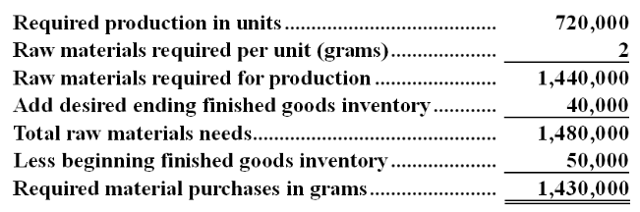

AACSB: Analytic
AICPA BB: Critical Thinking
AICPA FN: Measurement
Blooms: Application
Garrison - Chapter 08 #58
Learning Objective: 08-04 Prepare a direct materials budget; including a schedule of expected cash disbursements for purchase of materials
Level: Medium
37. The manufacturing overhead budget at Latronica Corporation is based on budgeted direct labor-hours. The direct labor budget indicates that 7,100 direct labor-hours will be required in August. The variable overhead rate is $8.60 per direct labor-hour. The company's budgeted fixed manufacturing overhead is $132,770 per month, which includes depreciation of $24,850. All other fixed manufacturing overhead costs represent current cash flows. The company recomputes its predetermined overhead rate every month. The predetermined overhead rate for August should be:
A. $8.60
B. $27.30
C. $23.80
D. $18.70
E. $12.10
Manufacturing Overhead Rate
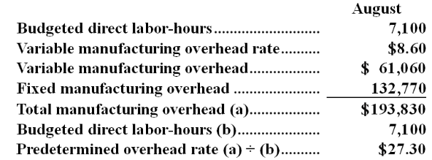

AACSB: Analytic
AICPA BB: Critical Thinking
AICPA FN: Measurement
Blooms: Application
Garrison - Chapter 08 #31
Learning Objective: 08-06 Prepare a manufacturing overhead budget
Level: Easy
38. The selling and administrative expense budget of Breckinridge Corporation is based on budgeted unit sales, which are 5,500 units for June. The variable selling and administrative expense is $1.00 per unit. The budgeted fixed selling and administrative expense is $101,200 per month, which includes depreciation of $6,050 per month. The remainder of the fixed selling and administrative expense represents current cash flows. The cash disbursements for selling and administrative expenses on the June selling and administrative expense budget should be:
A. $100,650
B. $106,700
C. $5,500
D. $95,150
Selling and Administrative Expense Budget
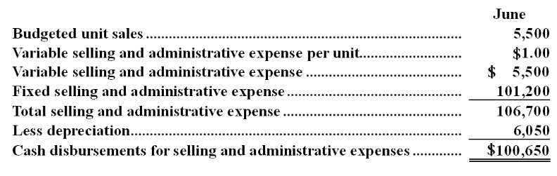

AACSB: Analytic
AICPA BB: Critical Thinking
AICPA FN: Measurement
Blooms: Application
Garrison - Chapter 08 #34
Learning Objective: 08-07 Prepare a selling and administrative expense budget
Level: Easy
USE THE FOLLOWING INFORMATION TO ANSWER THE NEXT QUESTION
Carpon Lumber sells lumber and general building supplies to building contractors in a medium-sized town in Montana. Data regarding the store's operations follow:
• Sales are budgeted at $340,000 for November, $350,000 for December, and $370,000 for January.
• Collections are expected to be 55% in the month of sale, 44% in the month following the sale, and 1% uncollectible.
• The cost of goods sold is 75% of sales.
• The company desires to have an ending merchandise inventory equal to 60% of the next month's cost of goods sold. Payment for merchandise is made in the month following the purchase.
• Other monthly expenses to be paid in cash are $21,100.
• Monthly depreciation is $19,000.
• Ignore taxes.
Garrison - Chapter 08
39. Accounts payable at the end of December would be:
A. $271,500
B. $105,000
C. $166,500
D. $262,500
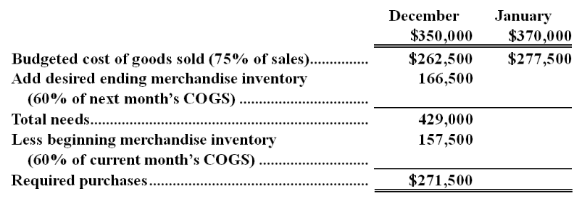
Since purchases are paid in the month following purchase, the accounts payable at the end of December should be $271,500.

AACSB: Analytic
AICPA BB: Critical Thinking
AICPA FN: Measurement
Blooms: Application
Garrison - Chapter 08 #94
Learning Objective: 08-10 Prepare a budgeted balance sheet
Level: Hard
40. The Willsey Merchandise Company has budgeted $40,000 in sales for the month of December. The company's cost of goods sold is 30% of sales. If the company has budgeted to purchase $18,000 in merchandise during December, then the budgeted change in inventory levels over the month of December is:
A. $6,000 increase
B. $10,000 decrease
C. $22,000 decrease
D. $15,000 increase
COGS = 0.30 × $40,000 = $12,000
Beginning merchandise inventory + Merchandise purchases = Ending merchandise inventory + COGS
Ending merchandise inventory - Beginning merchandise inventory = Merchandise purchases - COGS
= $18,000 - $12,000 = $6,000

AACSB: Analytic
AICPA BB: Critical Thinking
AICPA FN: Measurement
Blooms: Application
Garrison - Chapter 08 #26
Learning Objective: 08-03 Prepare a production budget
Level: Hard

Acct 2101 - Test 2 - F14 Summary
Category | # of Questions
AACSB: Analytic | 19
AACSB: Ethics | 5
AACSB: Reflective Thinking | 15
AICPA BB: Critical Thinking | 32
AICPA BB: Global | 1
AICPA BB: Industry | 3
AICPA BB: Legal | 1
AICPA BB: Resource Management | 2
AICPA FN: Measurement | 23
AICPA FN: Research | 13
AICPA FN: Risk Analysis | 3
Blooms: Application | 1
Blooms: Application | 1
Blooms: Application | 1
Blooms: Application | 1
Blooms: Application | 1
Blooms: Application | 1
Blooms: Application | 1
Blooms: Application | 1
Blooms: Application | 1
Blooms: Apply | 10
Blooms: Knowledge | 1
Blooms: Knowledge | 1
Blooms: N | 1
Blooms: RC | 1
Blooms: Remember | 6
Blooms: Understand | 10
Difficulty: 1 Easy | 7
Difficulty: 2 Medium | 9
Difficulty: 3 Hard | 10
Difficulty: Easy | 1
Difficulty: Medium | 1
Garrison - Chapter 05 | 7
Garrison - Chapter 08 | 8
Hilton - Appendix I... | 4
Hilton - Chapter 005 | 1
Hilton - Chapter 05 | 2
Hilton - Chapter 07 | 10
Hilton - Chapter 09 | 11
Learning Objective: 05-01 Explain how changes in activity affect contribution margin and net operating income | 1
Learning Objective: 05-04 Show the effects on net operating income of changes in variable costs; fixed costs; selling price; and volume | 2
Learning Objective: 05-06 Determine the break-even point | 2
Learning Objective: 05-08 Explain the concepts of activity-based management and two-dimensional ABC. | 1
Learning Objective: 05-11 List and explain eight important features of just-in-time inventory and production management systems (Appendix). | 1
Learning Objective: 07-01 Compute a break-even point using the contribution-margin approach and the equation approach. | 4
Learning Objective: 07-02 Compute the contribution-margin ratio and use it to find the break-even point in sales dollars. | 1
Learning Objective: 07-03 Prepare a cost-volume-profit (CVP) graph and explain how it is used. | 1
Learning Objective: 07-04 Apply CVP analysis to determine the effect on profit of changes in fixed expenses; variable expenses; sales prices; and sales volume. | 2
Learning Objective: 07-06 List and discuss the key assumptions of CVP analysis. | 1
Learning Objective: 07-08 Explain the role of cost structure and operating leverage in CVP relationships. | 1
Learning Objective: 08-01 Understand why organizations budget and the processes they use to create budgets | 1
Learning Objective: 08-03 Prepare a production budget | 1
Learning Objective: 08-04 Prepare a direct materials budget; including a schedule of expected cash disbursements for purchase of materials | 1
Learning Objective: 08-06 Prepare a manufacturing overhead budget | 1
Learning Objective: 08-07 Prepare a selling and administrative expense budget | 1
Learning Objective: 08-10 Prepare a budgeted balance sheet | 1
Learning Objective: 09-02 List and explain five purposes of budgeting. | 2
Learning Objective: 09-05 Prepare each of the budget schedules that make up the master budget in a nonmanufacturing firm; and that exist in manufacturing budgets as well. | 8
Learning Objective: 09-08 Describe a typical organizations process of budget administration. | 1
Learning Objective: 09-09 Discuss the behavioral issues in budgeting. | 1
Learning Objective: 11 | 1
Learning Objective: I-01 Understand and discuss the concept of internal controls over financial reporting. | 3
Learning Objective: I-02 Understand and discuss the role of the PCAOB and the implications of Sarbanes-Oxley Sections 302 and 404. | 1
Level: Easy | 4
Level: Hard | 4
Level: Medium | 3
Source: CMA, adapted | 1
University of... | 2

